**Introduction to Hardware Components**

Computers are built from various hardware components that work together to process, store, and manage data. Understanding these components is essential for selecting, maintaining, and troubleshooting a computer system. This document provides an in-depth overview of key hardware components, including the CPU, memory, hard disk, and more.

**1. Motherboard**

The motherboard is the main circuit board that connects and allows communication between all hardware components. It contains:

* **Chipset**: Manages data flow between CPU, memory, and peripherals.
* **Expansion Slots**: Allow additional components like graphics cards, network cards, and sound cards.
* **Ports and Connectors**: Include USB, HDMI, Ethernet, and audio jacks for connecting peripherals and external devices.
* **BIOS/UEFI Firmware**: Essential software embedded in the motherboard that helps in booting and system configuration.

Motherboards vary in form factors such as ATX, Micro-ATX, and Mini-ITX, catering to different computing needs.

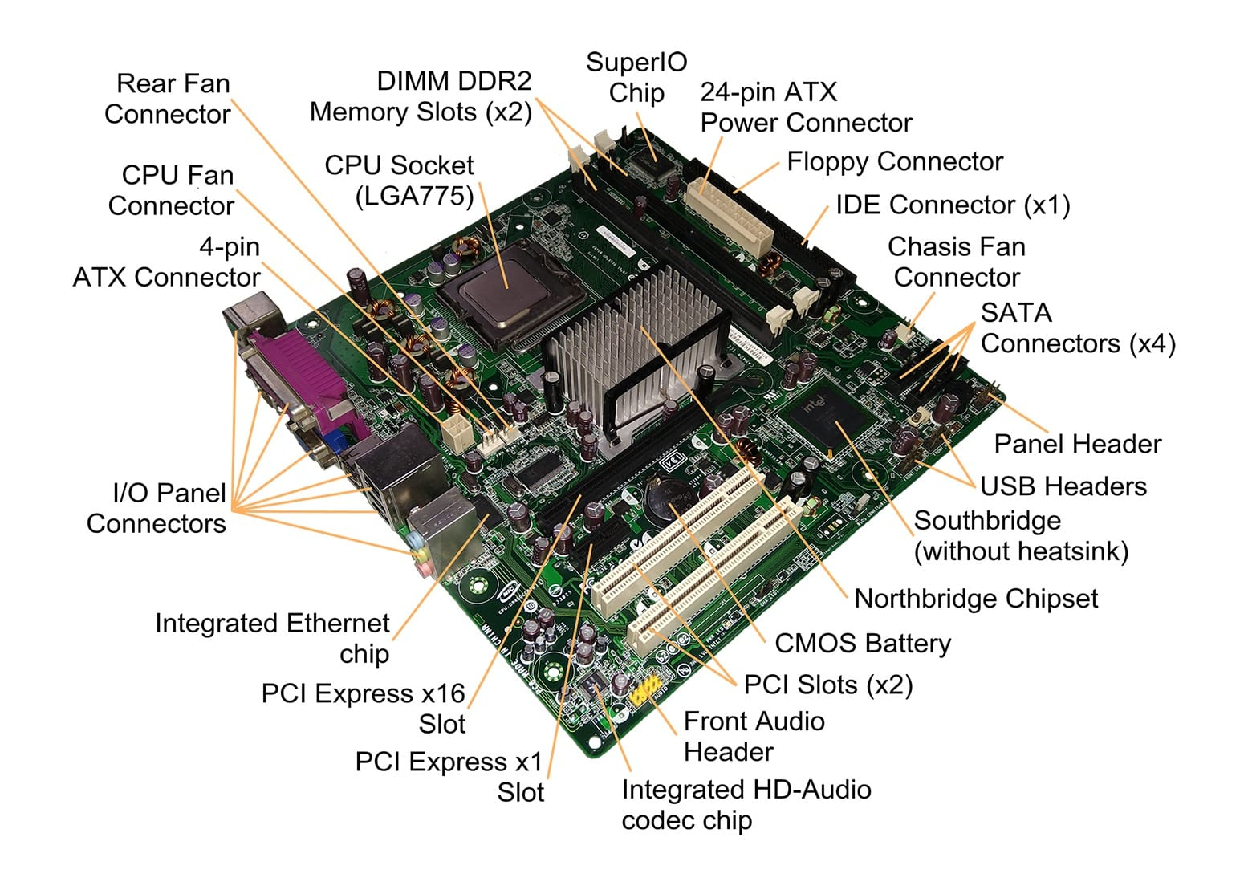

### 2. ****Random Access Memory (RAM)****

RAM is the temporary, high-speed memory that stores data and instructions for quick access by the CPU. It helps improve system performance by reducing the need to retrieve data from slower storage devices.

### ****Main Components:****

* **Memory Cells:** Store data as electrical charges.
* **Address Bus:** Helps the CPU locate data within RAM.
* **Data Bus:** Transfers data between RAM and other components.
* **Control Circuitry:** Manages read/write operations and refresh cycles.

### ****Key Performance Factors:****

* **Capacity (GB):** More RAM allows for better multitasking and performance.
* **Speed (MHz/MT/s):** Higher speeds enable faster data access.
* **Latency (CL):** Lower latency means quicker response times.
* **Type (DDR3, DDR4, DDR5):** Newer generations offer higher speed and efficiency.

### ****Major Manufacturers:****

* **Corsair**
* **G.Skill**
* **Kingston**
* **Crucial**
* **TeamGroup**

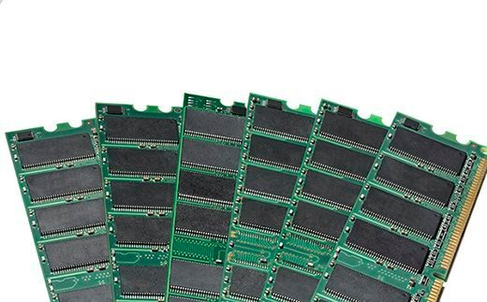

### 3.Daughter Cards

A **daughter card** (or **daughterboard**) is a circuit board that connects to the main motherboard or another expansion card to provide additional functionality. It enhances or extends the capabilities of a computer or electronic device.

**Main Features:**

* Plugs into a motherboard or another card via slots or connectors.
* Adds or improves system functionality (e.g., graphics, sound, networking).
* Often used when built-in motherboard features are insufficient.

**Common Types of Daughter Cards:**

* **Graphics Card (GPU):** Enhances visual performance for gaming, design, and AI tasks.
* **Sound Card:** Improves audio quality beyond onboard sound.
* **Network Interface Card (NIC):** Provides wired or wireless networking capabilities.
* **RAID Controller Card:** Manages multiple storage drives for performance and redundancy.
* **Capture Card:** Enables video and audio input for streaming or recording.
* **FPGA or AI Accelerator Cards:** Used for high-performance computing and deep learning tasks.

**Major Manufacturers:**

* **NVIDIA, AMD** (for GPUs)
* **ASUS, MSI, Gigabyte** (for various expansion cards)
* **Creative Labs** (for sound cards)
* **Intel, TP-Link** (for network cards)

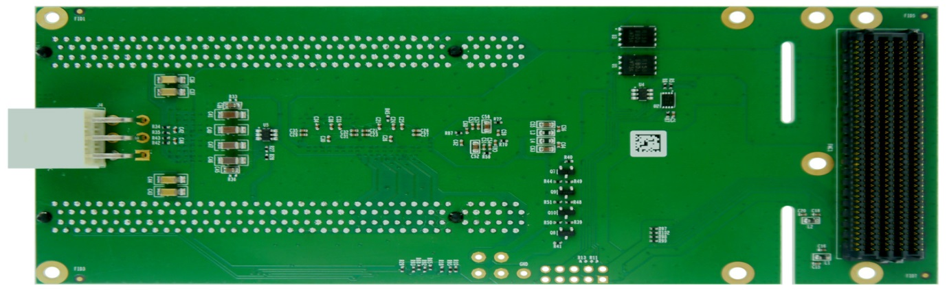

### 4. ****Bus Slots****

Bus slots are expansion interfaces on a motherboard that allow additional hardware components (such as graphics cards, network cards, or sound cards) to be connected. They enable communication between the motherboard and peripheral devices.

### ****Types of Bus Slots:****

#### ****1. PCI (Peripheral Component Interconnect)****

* Older standard, mostly replaced by PCIe.
* Used for legacy expansion cards like older sound and network cards.

#### ****2. PCI Express (PCIe)**** (Modern Standard)

* Faster and more efficient than PCI.
* Available in different sizes: **PCIe x1, x4, x8, x16, x32** (more lanes = higher speed).
* Used for GPUs, SSDs, RAID controllers, and other high-speed devices.

#### ****3. AGP (Accelerated Graphics Port)**** (Obsolete)

* Designed for older graphics cards before PCIe became standard.

#### ****4. ISA (Industry Standard Architecture)**** (Obsolete)

* Used in very old computers for expansion cards like sound and network adapters.

#### ****5. CNR (Communication and Networking Riser)**** (Obsolete)

* Used for networking and modem cards in older systems.

#### ****6. AMR (Audio Modem Riser)**** (Obsolete)

* Designed for audio and modem cards in older PCs.

### ****Key Factors to Consider:****

* **Compatibility:** Ensure the slot type matches your expansion card.
* **Speed & Bandwidth:** PCIe offers the best performance for modern hardware.
* **Number of Lanes (x1, x4, x8, x16):** Determines data transfer speed.

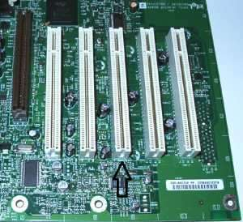

### 5. Switched-Mode Power Supply (SMPS)

The **Switched-Mode Power Supply (SMPS)** is an electronic power supply that converts electrical power efficiently using switching regulators. It supplies stable voltage to the computer's components while minimizing energy loss.

**Main Functions:**

* Converts **AC (Alternating Current) to DC (Direct Current)**.
* Regulates voltage levels for different computer components.
* Protects against power fluctuations and short circuits.

**Key Components:**

* **Rectifier & Filter:** Converts AC to DC and smooths the voltage.
* **Switching Regulator:** Uses high-frequency switching for efficient power conversion.
* **Transformer:** Adjusts voltage levels.
* **Output Stage:** Provides power to different components.

**Power Ratings: *(Measured in Watts - W)***

* **300W – 500W:** Basic office and low-power systems.
* **500W – 750W:** Mid-range gaming and workstation PCs.
* **750W – 1200W:** High-end gaming, servers, and multi-GPU setups.

**Types of SMPS Form Factors:**

* **ATX Power Supply:** Common in desktops.
* **SFX Power Supply:** Used in small form factor PCs.
* **Redundant Power Supply:** Used in servers for reliability.

**Key Features to Look For:**

* **80 PLUS Certification (Efficiency Ratings: Bronze, Silver, Gold, Platinum, Titanium).**
* **Modular, Semi-Modular, or Non-Modular (for cable management).**
* **Overvoltage, Overcurrent, and Short-Circuit Protection.**

**Popular Brands:**

* **Corsair**
* **Seasonic**
* **Cooler Master**
* **EVGA**
* **Thermaltake**

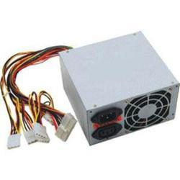

### 6. ****Internal Storage Devices****

Internal storage devices store operating systems, software, and user data inside a computer. They provide primary data storage for long-term access.

### ****Types of Internal Storage Devices:****

#### ****1. Hard Disk Drive (HDD)****

* Uses spinning magnetic platters and a mechanical arm to read/write data.
* **Advantages:** High capacity (1TB–18TB), cost-effective.
* **Disadvantages:** Slower speeds, mechanical wear over time.

#### ****2. Solid-State Drive (SSD)****

* Uses NAND flash memory for faster data access and durability.
* **Advantages:** High speed, no moving parts, energy-efficient.
* **Disadvantages:** More expensive than HDDs for the same capacity.

#### ****3. NVMe SSD (Non-Volatile Memory Express)****

* Advanced SSD connected via PCIe for ultra-fast performance.
* **Advantages:** Speeds up to 7000MB/s, low latency, ideal for gaming and high-performance computing.
* **Disadvantages:** More expensive than SATA SSDs.

#### ****4. eMMC (Embedded MultiMediaCard)****

* Flash storage used in budget laptops, tablets, and mobile devices.
* **Advantages:** Compact and affordable.
* **Disadvantages:** Slower than SSDs, limited lifespan.

#### ****5. Hybrid Drive (SSHD - Solid State Hybrid Drive)****

* Combines HDD capacity with SSD speed by storing frequently used files on flash memory.
* **Advantages:** Better performance than HDD, more storage than SSD.
* **Disadvantages:** Slower than pure SSDs.

#### ****6. Internal Optical Drives (CD/DVD/Blu-ray Drives)**** (Less Common Today)

* Used for reading/writing CDs, DVDs, and Blu-rays.
* **Advantages:** Useful for media playback and archival storage.
* **Disadvantages:** Slower, becoming obsolete.

### ****Key Factors When Choosing Internal Storage:****

* **Capacity:** HDDs (1TB+), SSDs (256GB+), NVMe (500GB+).
* **Speed:** NVMe SSDs > SATA SSDs > HDDs.
* **Durability:** SSDs last longer than HDDs due to no moving parts.
* **Usage:** NVMe SSDs for high-performance tasks, HDDs for bulk storage.

### ****Popular Brands:****

* **Seagate, Western Digital (WD)** – HDDs & SSDs
* **Samsung, Crucial, Kingston** – SSDs & NVMe
* **Toshiba, SanDisk, Intel** – Various storage solutions

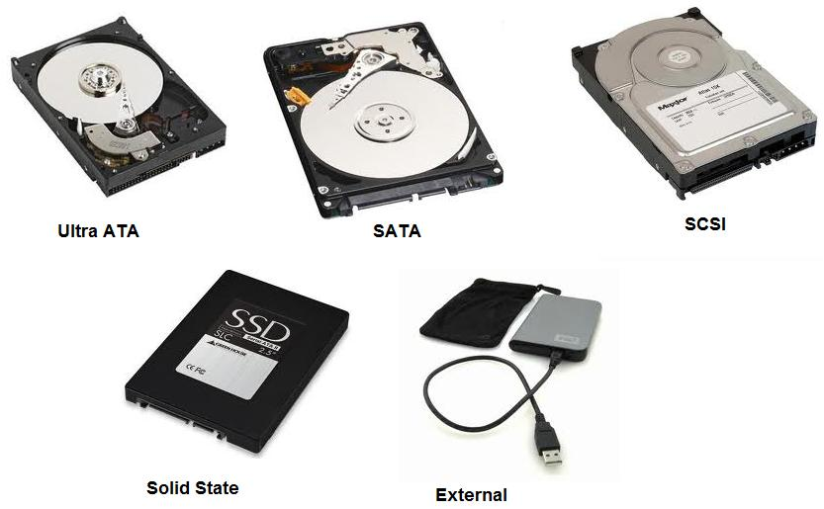

### ****7.Interfacing Ports****

Interfacing ports are physical or wireless connection points on a computer or device that enable communication with peripherals and other systems.

### ****Types of Interfacing Ports:****

#### ****1. Data Transfer Ports:****

* **USB (Universal Serial Bus)**
  + **USB 2.0** (480 Mbps) – Older, slower.
  + **USB 3.0/3.1/3.2** (5–20 Gbps) – Faster data transfer.
  + **USB-C** (up to 40 Gbps with Thunderbolt) – Reversible, high-speed.
* **Thunderbolt (by Intel & Apple)**
  + Supports data, video, and power in one port.
  + Thunderbolt 3 & 4 (up to 40 Gbps).
* **FireWire (IEEE 1394)** (Obsolete)
  + Used for video editing and older external drives.

#### ****2. Display & Audio Ports:****

* **HDMI (High-Definition Multimedia Interface)** – Transmits both video & audio.
* **DisplayPort (DP)** – Used for high-resolution monitors and gaming setups.
* **VGA (Video Graphics Array)** (Obsolete) – Analog video for older displays.
* **DVI (Digital Visual Interface)** (Less Common) – Used in older monitors.
* **3.5mm Audio Jack** – Connects headphones, speakers, and microphones.
* **Optical Audio (TOSLINK)** – High-quality digital audio for home theaters.

#### ****3. Networking & Communication Ports:****

* **Ethernet (RJ45)** – Wired networking (10Mbps–10Gbps).
* **Wi-Fi & Bluetooth (Wireless)** – For internet and device connectivity.
* **RJ11 (Telephone Jack)** – Used for dial-up modems (Obsolete).

#### ****4. Storage & Expansion Ports:****

* **SATA (Serial ATA)** – Connects HDDs, SSDs, and optical drives.
* **eSATA (External SATA)** – Used for external hard drives (Less common now).
* **NVMe (PCIe-based SSDs)** – High-speed SSD storage interface.
* **SD Card Slot** – Reads memory cards (used in cameras & laptops).

#### ****5. Peripheral & Legacy Ports:****

* **PS/2 (Keyboard & Mouse)** (Obsolete) – Found in older PCs.
* **Serial Port (RS-232, COM Port)** (Obsolete) – Used for legacy devices.
* **Parallel Port (LPT)** (Obsolete) – Previously used for printers.

### ****Choosing the Right Port:****

* **For fast data transfer:** USB 3.2, USB-C, Thunderbolt.
* **For high-quality display:** HDMI, DisplayPort.
* **For networking:** Ethernet, Wi-Fi.
* **For legacy compatibility:** VGA, Serial, PS/2.

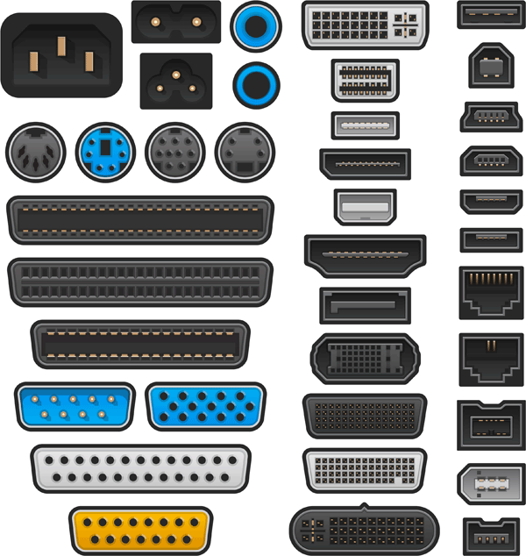

**Conclusion**

Understanding hardware components is crucial for optimizing a computer’s performance. A solid grasp of these components ensures better decision-making and system maintenance.